Part 4

Develop a simple dynamic website to integrate the above concepts. Document your work by saving your code and screen shots in your Word document.

URL: localhost:4200

Login Page:

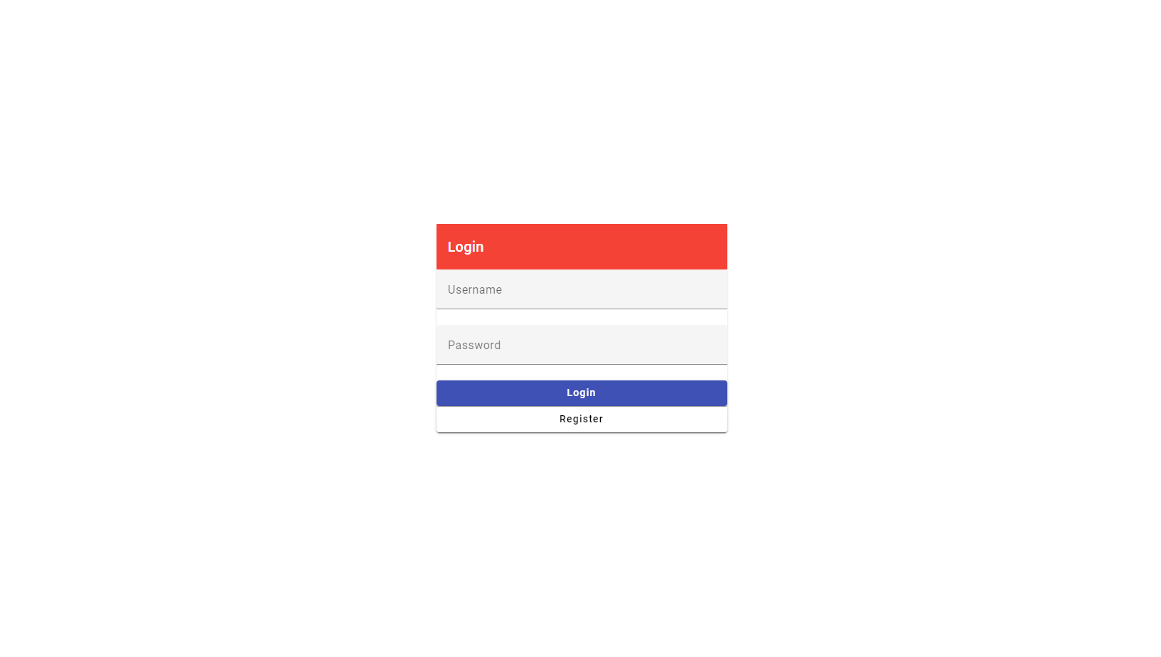

Registration Page:

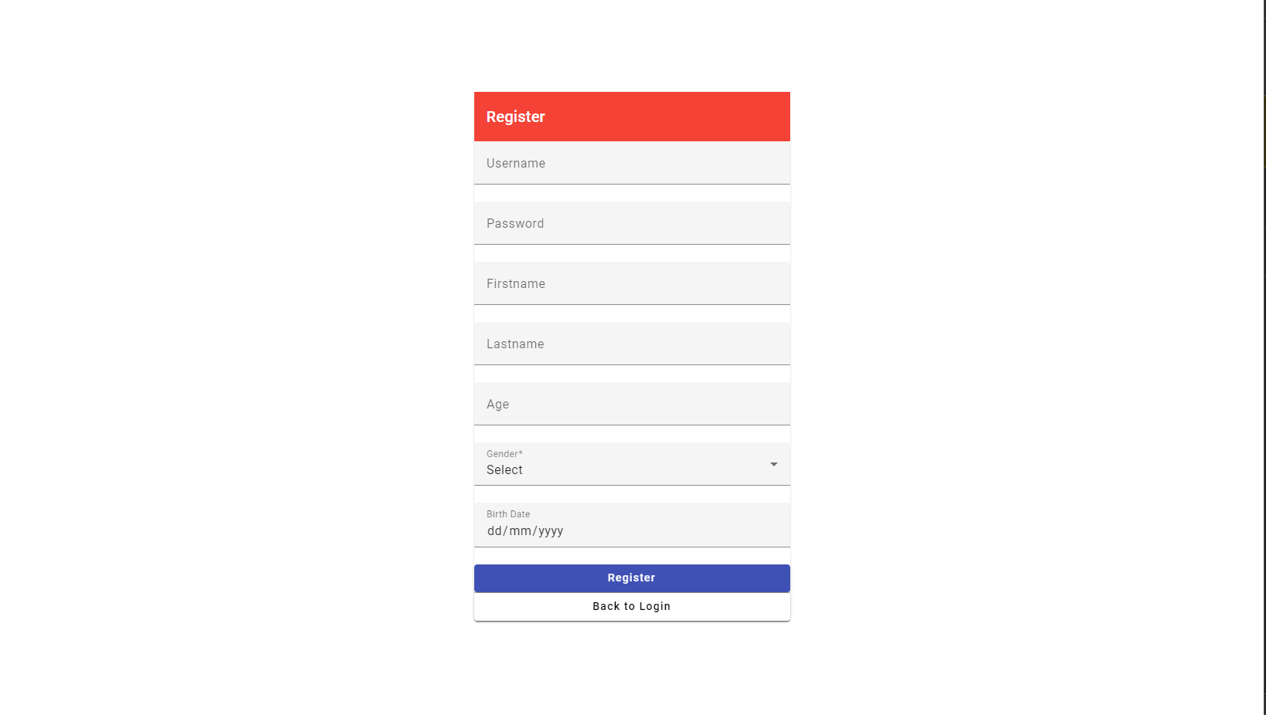

Homepage:

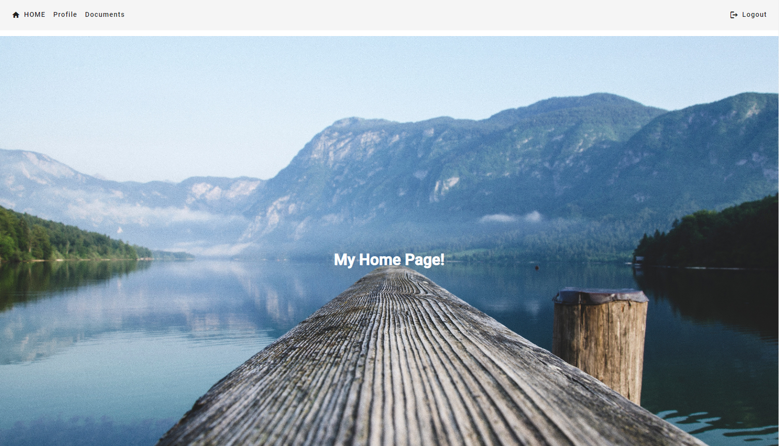

Profile Page:

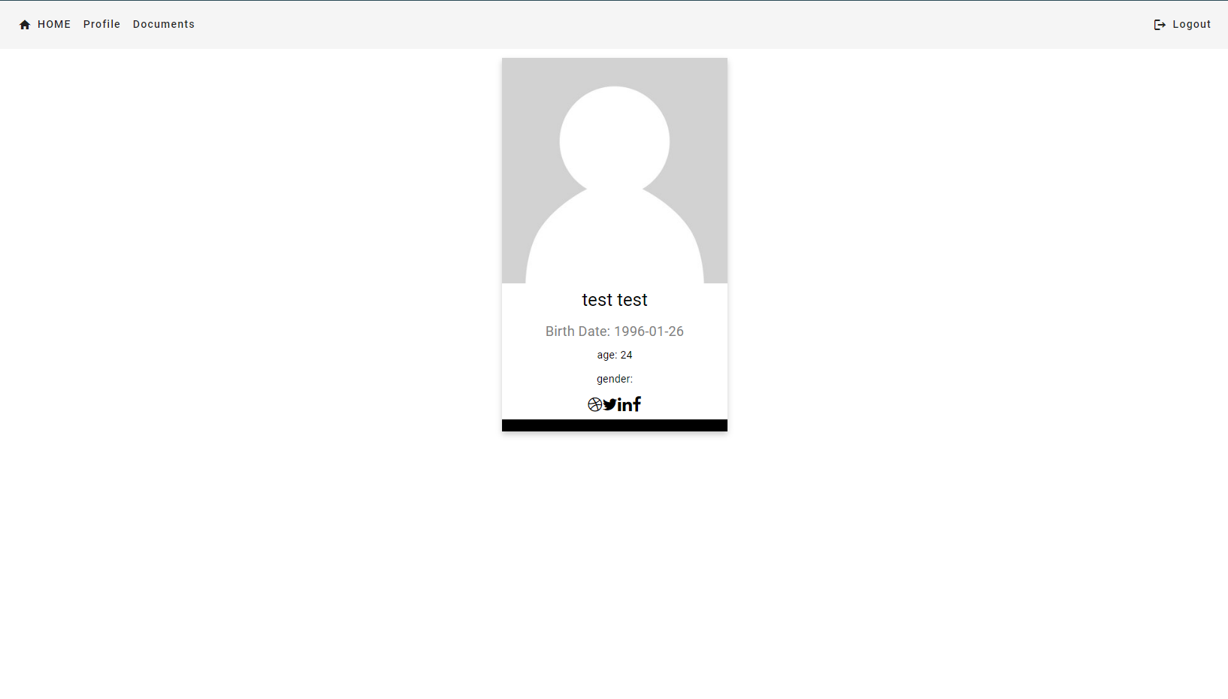

Document Page:

